 Order Form for Sol Shapes Surfboards...
Kai Dilling
1170 Lazy Lane
Mount Pleasant, SC 29464
843-345-6765
e-mail: kai@solsurfers.net

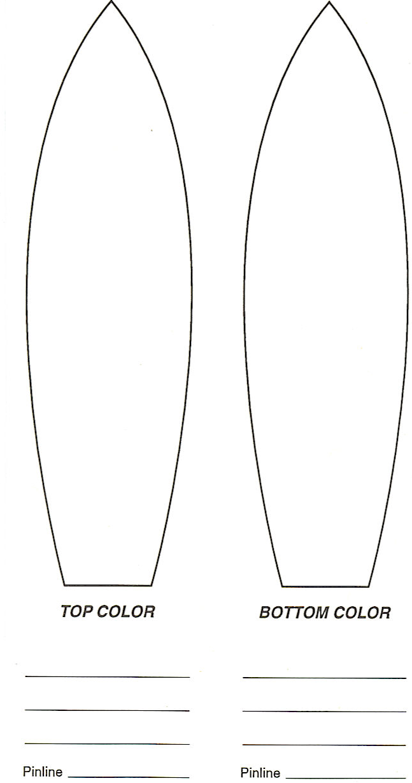
Name: ___________________________

Ht:______________ Wt: _____________

Phone: ___________________________

Length: __________________________

Width: ___________________________

Nose: ___________ Tail: ____________

Fin: ______________________________

__________________________________

__________________________________

Glassing

Deck: ____________________________

Bottom: __________________________

Sand-out or Gloss

Notes

__________________________________

__________________________________

__________________________________

__________________________________

__________________________________

__________________________________

